 |  | EDUCATION
12th Class: - Passed with commerce stream.
Marks:- 80%

Graduation:- B.Com Program Perusing with University of Delhi ( SOL )

1st Year Marks:- 75%
2nd Year :- 80%
3rd Year :- Perusing
Arun Kumar  (Digital Marketing Team Lead & Trainer)  Profile  To prove myself dedicated, valuable and energetic in progressive organization that gives me scope to apply my knowledge and skills and be a member of a team that dynamically works towards the success and growth of the organization and to emerge as a successful leader in the future.  CONTACT  PHONE:  7291000750  WEBSITE:  https://dmkarunkumar.com  Email:- Arun.mktg8@gmail.com |  | Work Experience (3 Years )
- Online Strikers ( Search Engine Executive )
May 2019– February 2020 ( 11 Months )

Company’s Activities were dealing with the Clients in Digital Marketing industry

- Ziyyara Edutech ( Digital Marketing Team Leader with SEO Specialization)
March 2020– October 2021 ( 1 Year 8 Months )

Company was in Edtech industry and activities were dealing with academics students

- Caba Innovatives ( Digital Marketing Lead & Trainer )
October–working in Present

Company Dealing with the Students of Digital Marketing and multimedia courses with having Good Command on own Projects.

 |  | Top 5 Skills



- RESPONSIBILITIES AN SEO SPECIALIST:

On–Page Search Engine Optimization–SEO

- Meta Title
- Meta Description
- Keyword Density
- Meta Keyword
- URL Optimization
- Keyword Cannibalization
- Canonical Optimization
- EAT Optimization
- Number of Linking Page
- Length of Contact
- Duplicate Content
- Image Optimization
- Outbound Linking
- Internal Linking
- Anchor Text Optimization
- Link Relevance
- Do-follow and No-follow Optimization
- Broken Internal and Outbound Links
- Open Graph Tag
- Meta Itemprop

Off–Page Search Engine Optimization

- Directory Submissions
- Bookmarking submission
- Social Bookmarking Submission
- Classified Submission
- Profile Creation
- Question and Answers Submission
- Web 2.0 Submission
- Form Submission
- Article submission
- Blog Submission
- Guest Posting
- Ping Submission
- PDF Submission
- PPT Submission
- Image Submission

Technical SEO

1. Indexation Issue
2. Mobile-Friendly
3. Broken Links
4. Site with HTTPS
5. Site’s Loading Speed
6. XML sitemap
7. Enabling AMP
8. Robots.Txt
9. Schema Markup Language
10. 404 Page Optimization
11. 301 and 302 Redirection optimization
12. Core web Vitals
13. Robots.txt
14. HTML Error and Warning
15. Check Google Panalty

SEO Tools

- Google Analytics
- Google Search Console
- Keyword Planner
- Ubbersuggest
- Ahref
- Semrush
- Many other as well.

Note:- I know how to automate SEO with on advance Level.

Google Algorithms

- Panda
- Rankbrain
- Hummingbird
- Panda
- Penguin
- Pigeon
- BERT
- RESPONSIBILITIES AS SMO

1. Making the awareness of Company
2. Creating the Company's Page
3. Creating the Company's Groups
4. Finding the right audience for Company's niche related
5. Finding the Right Groups for Company’s niche related
6. Collective the audience with pages and Groups
7. Doing the Daily Audience target with Awareness strategies
8. Daily post on the company's Facebook Page, monitor insights of the post and story and start a conversation.
9. Create and maintain engagement on posts.
10. Attract and gain followers
11. Sharing the posts in groups, market places.
12. Managing all the accounts of Social Media (Facebook, LinkedIn, Twitter, Instagram )
13. Building and maintain our social media presence on Search Engine
14. Creating the Creative content for info graphic
3. RESPONSIBILITIES AS SMM AND PPC

- Launch and optimize at least 30 paid campaigns each month
- Ensure proper tracking set up in the social platforms (Facebook, Instagram, LinkedIn, Twitter)
- Create and maintain Paid Social strategy programs for new and existing campaigns.
- Manage the daily campaign optimization efforts to ensure they are achieving the reach, engagement, and conversion goals.
- Create, curate, and manage all published content (images, video, and content)
- Produce detailed reports analyzing paid social media campaigns.
- Manage bid rules and optimization efforts at the campaign, audience, and ad levels.
- Keep current on industry and propose new ideas to further enhance campaign tactics and performance.

Other Advanced Skills

4. Wordpress website designing
5. Online Reputation Management
6. Email Marketing
7. Lead Generation through SEO, SMO, PPC
8. Google My Business
9. Bing Page Creation and Webmaster handling
10. Google Adsense
11. Affiliate Marketing
12. Amazon Ecommerce

Working Domains (More than 10+)

- dmkarunkumar.com ( My own Domain for Personal Branding )

- Ziyyara.com
- Ziyyara.in
- Muscathome.com
- 360degreejobs.com
- Alatestnews.com
- Alatestnews.in
- seelatest.in
- digitalsportsinfo.com
- top10desire.com
- teachmetechno.com
- learnedutech.com
- roundworldstory.com
- asdigimarketing.com

Experience as Digital Marketing Trainer & Academic Tutor
Training Period: - I have taught more than 10 students in last 1 year and they all have gotten the job in the corporate sector.
Experience: - 1 and Half year

Academic Tuition: - I have taught to the students who were 6 – 12th Class.
Experience: - 2 Years
Some of the Glimpses as Personal Branding
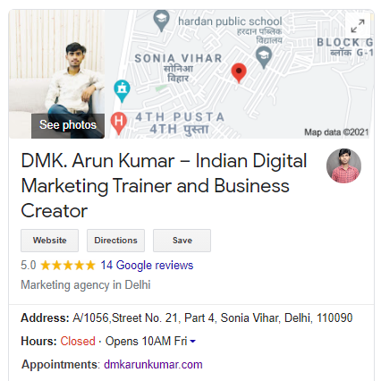
Featured on Bing
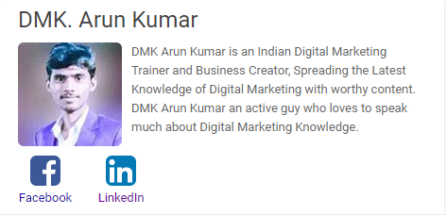
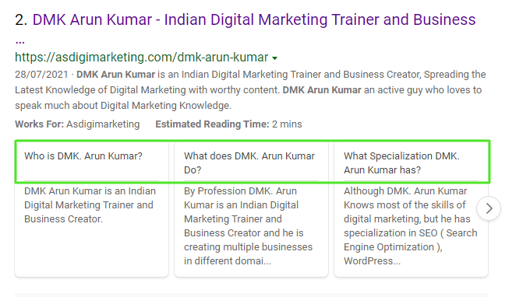
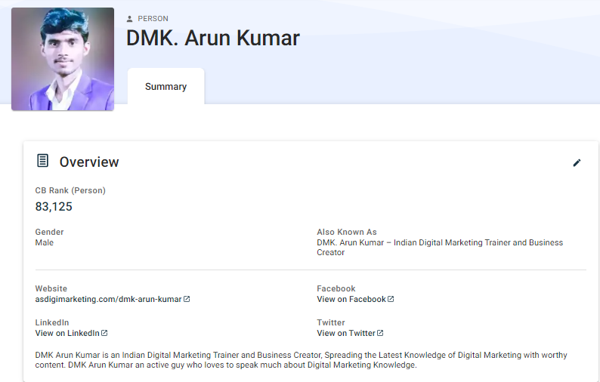
Some of the Best Keywords Which I have ranked

- online tuition
- online tuitions
- online tution
- tuition website
- online tuition classes
- online tuition websites
- online tuition sites
- online tuition in india
- online tuition classes in india
- online tutoring sites in india

- algebra in real life
- what is algebra used for
- why is algebra important
- algebra in everyday life
- why do we need algebra
- application of algebra
- uses of algebra
- using algebra in real life

PERSONAL ATTRIBUTES

Confident, Speaking, Leadership

HOBBIES

Reading, Teaching and Teaching

PERSONAL DETAILS
Father’s Name: - India Pal
D.O.B:- 15 – March 2001
Nationality: - Indian
Language Known: - Hindi, English
Permanent Address: - A/1056, Street No. 21, Part 4, Sonia Vihar , Delhi, 110090

