DAILY CURRENT AFFAIRS 12TH NOVEMBER 2020

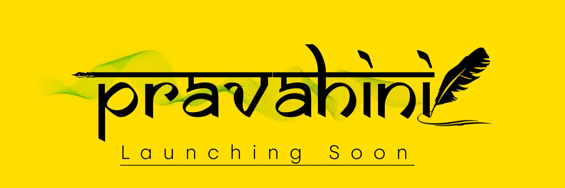

CHINA SEND WORLD'S FIRST 6G EXPERIMENT SATELLITE
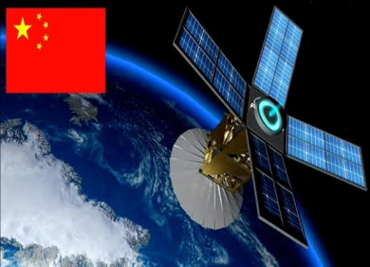
- China has sent into space the world’s first 6G experiment satellite. The 6G satellite was among three Chinese satellites successfully launched into orbit, along with 10 commercial remote sensing satellites developed by Argentinean Company Satellogic.

- As per the reports, the technology is expected to be over 100 times faster than 5G. The 6G communications test satellite was launched into the orbit along with 12 other satellites.

- The satellite also carries technology which will be used for crop disaster monitoring and forest fire prevention. This was the 351st rocket of China’s Long March series.

- China National Space Administration (CNSA) is the national space agency of China. It is responsible for the national space program and for planning and development of space activities.

- CNSA and China Aerospace Science and Technology Corporation (CASC) assumed the authority over space development efforts previously held by the Ministry of Aerospace Industry.

- It is a subordinate agency of the State Administration for Science, Technology and Industry for National Defence (SASTIND), itself a subordinate agency of the Ministry of Industry and Information Technology (MIIT).

- Capital of China Beijing.
- China Currency: Renminbi.
- Chinese President: Xi Jinping.
A-SAT MISSILE MODEL UNVEILED BY DEFENCE MINISTER
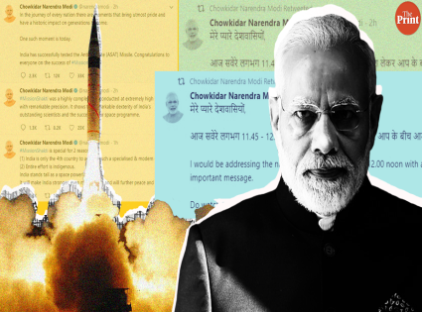
- A model of Anti Satellite (A-SAT) Missile installed inside DRDO Bhawan was unveiled by Union Defence Minister Rajnath Singh.

- The installation of the A-SAT model will inspire the DRDO fraternity to take up many more such challenging missions in future.

- ‘Mission Shakti’ was the country’s first-ever Anti-Satellite (A-SAT) Missile Test successfully conducted on 27th March 2019 from Dr APJ Abdul Kalam Island in Odisha.
- DRDO Chairman: Dr G. Satheesh Reddy.
- DRDO Headquarters: New Delhi.

INDIAN NAVY LAUNCHES SUBMARINE 'VAGIR'

- The Indian Navy has launched the fifth Scorpene submarine “Vagir” at Mazagon Dock of south Mumbai. The submarine is capable of taking missions such as anti-submarine warfare, anti-surface warfare, mine laying, intelligence gathering and area surveillance.
Features of Scorpene submarine “Vagir”
Vagir is a part of six Kalvari class submarines that is being built in India.
These submarines were designed by the French Navy and an energy company DCNS.
The six submarines were built under Project-75 of Indian Navy.
Vagir has been named after Sand Fish. It is a deep-sea predator in the Indian Ocean.
The first Vagir was commissioned in 1973. The first Vagir submarine was from Russia.

- Chief of Naval Staff: Admiral Karambir Singh.

VICE PRESIDENT LAUNCHED THE BOOK TITLED: THAVAASMI

- Vice President of India, Venkaiah Naidu has launched the book titled “Thavaasmi: Life and Skills through the lens of Ramayana”.

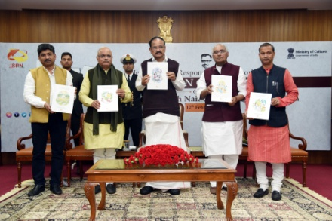
- The book was authored by Rallabandi Srirama Chakradhar and co-author by Amara Sarada Deepthi. Thavaasmi is in 4 volumes prepared by a team of young professionals.

- The book presents the story of Ramayana as a dialogue between a father and daughter with a number of exercises making it an interesting learning experience.

KASH PATEL NAMED AS CHIEF OF STAFF TO DEFENCE SECY

- Indian-American Kash Patel has been named as the Chief of Staff to the Acting US Defence Secretary Chris Miller.

- The new appointment comes a day after Donald Trump fired Defence Secretary Mark Esper and designated Chris Miller, as the Acting Secretary. Kash Patel, currently on the National Security Council staff. He replaces Jen Stewart, who resigned earlier in the day.
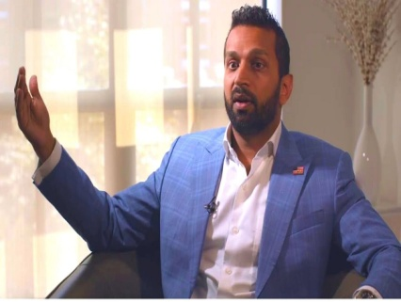
- Kashyap Pramod Patel, popularly known as Kash Patel, had previously served as senior counsel for counter-terrorism at the House Permanent Select Committee.

- In June 2019, Patel, 39, was appointed as senior director of Counter-terrorism Directorate of the National Security Council (NSC) in the White House.
NAVEEN PATNAIK LAUNCHED FHE SCHEME 'SECHA SAMADHAN'

- Chief Minister Naveen Patnaik has launched ‘Secha Samadhan’, a bilingual mobile application, to address the irrigation problems faced by farmers without them having to visit the offices concerned.

- With the launching of the application, farmers need not run to the offices of the Water Resources department and can send their grievances through photographs or videos. The farmers will be informed about the status of their complaints through SMS.
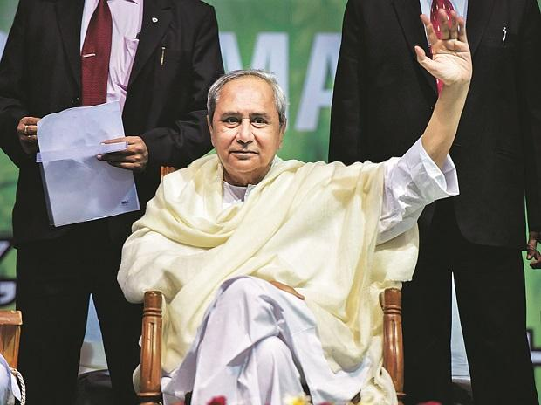
- Besides, immediate steps will be taken to redress the grievances of the farmers. He also launched four other online services to resolve the issue of water distribution for industries, commercial establishments and other institutions.

- Chief Minister of Odisha: Naveen Patnaik.
- Odisha Governor: Ganeshi Lal.

BAHRAIN LONGEST SERVING PM PASSES AWAY

- Bahrain’s Prime Minister Khalifa bin Salman al-Khalifa has passed away. He was 84. He was not only the longest-serving PM of Bahrain, but he was the world’s longest-serving prime minister.

- He had held the post since independence in 1971. He played a key role in Bahrain’s political and economic affairs for more than three decades after setting the stage for a referendum that put paid to the Shah of Iran’s claims to the tiny Gulf archipelago.

- He was born on November 24, 1935; Khalifa began to attend his father’s royal court at the age of seven along with his elder brother, Prince Issa.
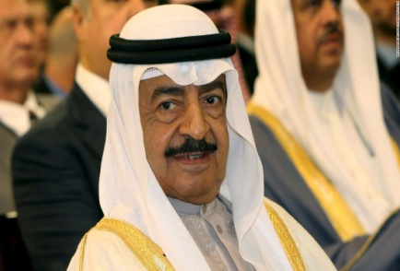
- He was named in 1970 as the head of the state council, the executive branch of government which became the council of ministers after independence from Britain.

- King of Bahrain: Hamad bin Isa Al Khalifa.
- Capital of Bahrain: Manama.

WORLD PNEUMONIA DAY 2020: 12TH NOVEMBER

- World Pneumonia Day is observed globally on 12th November every year.

- The day is celebrated to raise awareness, promote prevention and treatment and produce action to combat the disease. The day was first celebrated in the year 2009.

- To end the preventable burden of childhood pneumonia and deaths there is a need to:

Raise awareness about pneumonia, the leading killer of young children.
Strengthen, accelerate and sustain interventions to prevent and treat pneumonia.
Focus on equitable access to and delivery of comprehensive pneumonia prevention and control programs.
Design specific strategies to reach the “harder-to-reach” populations to improve their accessibility to available interventions.
Conduct research to develop innovative strategies to reduce the burden of pneumonia.

- The day was celebrated on November 12 in 2009 by the Global Coalition against Child Pneumonia. Since then the day has provided an annual forum for the world in standing together against the disease.
PUBLICATION SERVICE BROADCASTING DAY: 12TH NOVEMBER
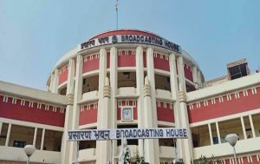
- Public Service Broadcasting Day is celebrated on 12 November every year. The day is celebrated to commemorate the first and only visit of the Father of the Nation, Mahatma Gandhi, to the studio of All India Radio, Delhi in 1947.

- On 12 November 1947, Mahatma Gandhi addressed the displaced people (a refugee from Pakistan), who had temporarily settled at Kurukshetra in Haryana after partition.

- The day was declared as Public Service Broadcasting Day or (Jan Prasaran Diwas) in 2000, after it was conceptualised by Suhas Borker, Convenor, Jan Prasar.

- Prasar Bharati has been given the responsibility of public service broadcasting, deepen democratic traditions and provide opportunities to all diverse communities and cultures.

- Mahatma Gandhi had decided to visit the studio of All India Radio, to convey his message through radio, as he couldn’t visit refugees of Partition stationed at Kurukshetra in Haryana.



