DAILY CURRENT AFFAIRS 16TH NOVEMBER 2020

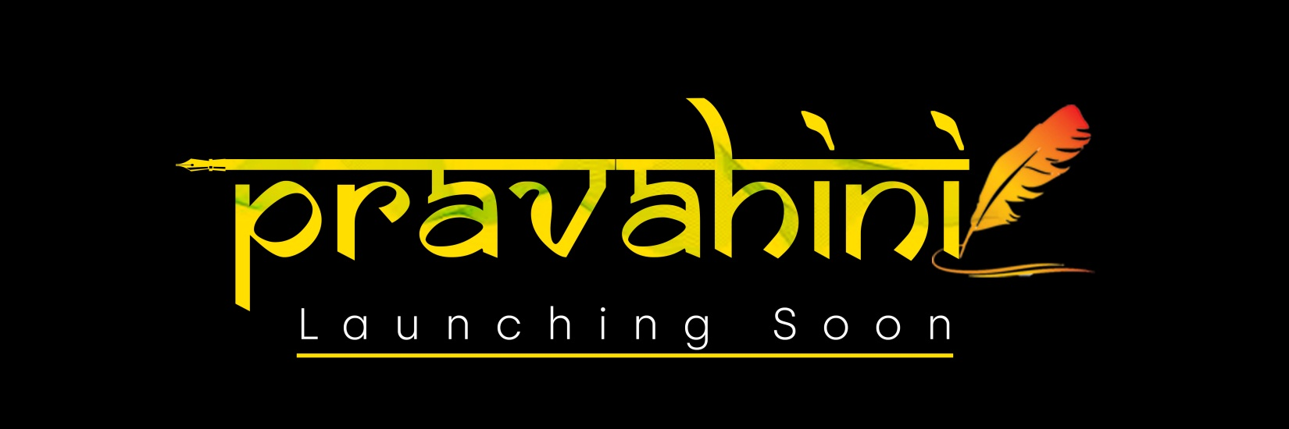

S. JAISHANKAR AT 15TH EAST ASIA SUMMIT 2020

- The External Affairs Minister Dr S. Jaishankar has represented India at the 15th East Asia Summit (EAS) on behalf of PM Modi.

- The Summit was chaired by the Prime Minister of Vietnam Nguyen Xuan Phuc because Vietnam is ASEAN Chair in 2020 (ASEAN holds the central role and leadership in the forum). All the 18 EAS countries participated in the virtual Summit.

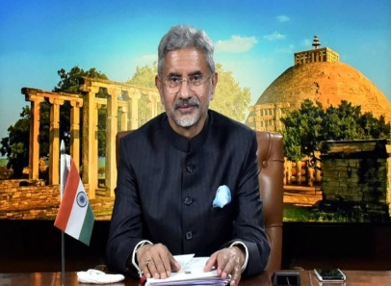
- Jaishankar underlined the key role played by the East Asia Summit (EAS) as a leading mechanism of the Indo-Pacific region and reiterated India’s support to make it stronger and more responsive.

- He also re-affirmed the importance of EAS as the Leaders-led forum to exchange views on strategic issues. On Covid-19, he briefed the EAS leaders about India’s response to the pandemic and highlighted India’s efforts to support the international community.

- The East Asia Summit (EAS) is a regional forum held annually by leaders of, initially, 16 countries in the East Asian, Southeast Asian, South Asian and Oceanian regions, based on the ASEAN Plus Six mechanism. Membership expanded to 18 countries including Russia and the United States at the Sixth EAS in 2011.

WORLD'S FIRST TRAM LIBRARY FOR CHILDREN IN WB

- On the occasion of Children’s Day, a first-of-its-kind in the world, library on the tram for children was launched in Kolkata, West Bengal. A tram is a rail vehicle that runs on tramway tracks along public streets.

- The tram would run on Shyambazar-Esplanade and Esplanade-Gariahat routes, spanning across north and south Kolkata, every day from morning to evening.

- It has been jointly developed by the West Bengal Transport Corporation (WBTC) and Apeejay Anand Children’s Library and will have around 1,000 books.

- Chief Minister of West Bengal: Mamata Banerjee.
- Governor of West Bengal: Jagdeep Dhankhar.

8TH BRICS STI MINISTERIAL MEETING HELD VIRTUALLY

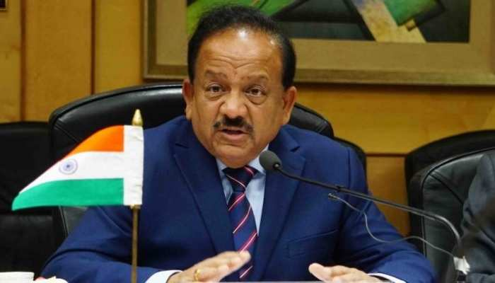
- The 8th BRICS Science, Technology and Innovation Ministerial Meeting was held through a virtual platform for Science and Technology cooperation among the member countries, which are Brazil, Russia, India, China and South Africa.

- The meeting was held under the Chairmanship of the Russian Federation. (Russia is the Chair for 12th BRICS Summit). The Union Minister of Science and Technology, Dr Harsh Vardhan represented the Indian delegation at the meeting.

- The meeting concluded with the adoption of BRICS STI Declaration 2020. During the meeting, Dr Harsh Vardhan highlighted that “The COVID 19 pandemic has been a test, demonstrating that multilateral cooperation is the key to overcoming such global challenges”.

- He reiterated that “India will actively contribute in the implementation of BRICS STI Calendar of Activities 2020-21 and supports continuation scientific activities under BRICS MOU on Science, Technology and Innovation”.
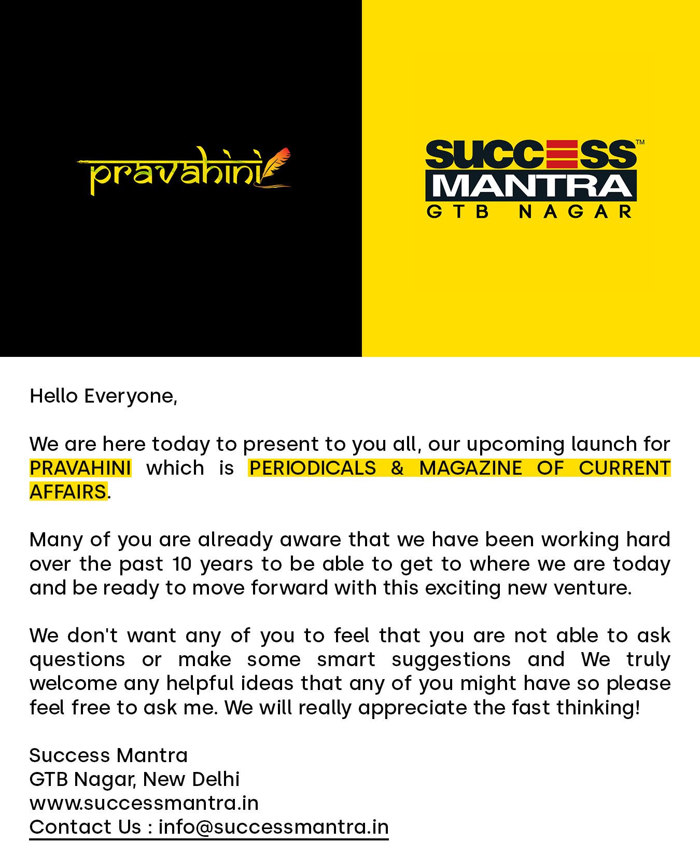
INDIA SUCCESSFULLY TEST-FIRED QRSAM SYSTEM

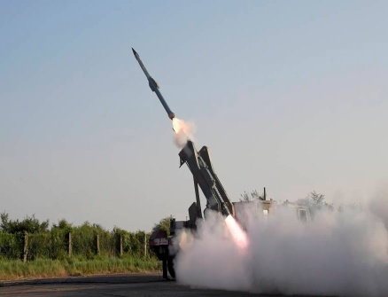
- India successfully test-fired the Quick Reaction Surface to Air Missile (QRSAM) system off the coast of Balasore in Odisha.

- The system achieved a major milestone by a direct hit on to a Banshee Pilotless target aircraft at medium range and medium altitude. Indian forces have carried out at least seven tests earlier of the missile system.

- The QRSAM system has been developed by the Defence Research and Development Organisation (DRDO) in association with Bharat Electronics Limited and Bharat Dynamics Limited for the Indian Army.

- The system is capable of detecting and tracking targets on the move and engaging target with short halts. The system is designed to give air defence coverage against strike columns of the Indian Army.

LONAR LAKE IN MAHARASHTRA CHOSEN AS RAMSAR SITE

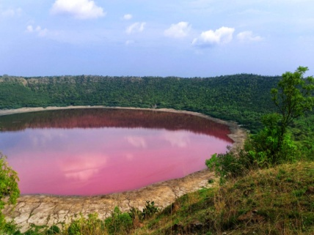
- The Lonar Lake in Buldhana district of Maharashtra has been chosen as a wetland site of international importance under the Ramsar conservation treaty.

- Lonar Lake was formed by the impact of a meteorite on basalt bedrock several thousand years ago. An area of 365 hectares around the lake, which itself is spread over 77.69 hectares, was declared a wildlife sanctuary in June 2000.

- A Ramsar Site is a wetland site designated to be of international importance under the Ramsar Convention. The name Ramsar comes from the Ramsar City of Iran, where this treaty was signed.

- The Convention on Wetlands is also known as the Ramsar Convention. It is an intergovernmental environmental treaty established in 1971 by UNESCO and came into force in 1975.

  - Chief Minister of Maharashtra: Uddhav Thackeray
  - Governor of Maharashtra: Bhagat Singh Koshyari.

LEWIS HAMILTON WINS TURKISH GRAND PRIX 2020
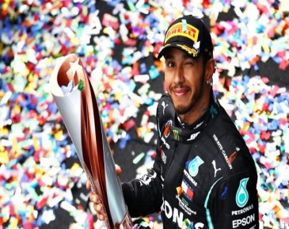
- Lewis Hamilton (Mercedes-Great Britain) has won the Turkish Grand Prix 2020 at Istanbul Park, Turkey.

- Sergio Perez (Racing Point-BWT- Mexico) secured the second position and Sebastian Vettel of Ferrari finished third. This was Hamilton 10th victory of the season and 94th F1 win of his career.

- With this win, he claimed the seventh Formula One championships title of his career to equal the record of Michael Schumacher.

INTERNATIONAL CHILDREN'S PEACE PRIZE 2020

- Sadat Rahman from Bangladesh has been awarded the prestigious International Children’s Peace Prize 2020.

- He was awarded the prize for his involvement in setting up his social organization and mobile app ‘Cyber Teens’ to stop cyberbullying.

- The award was presented to 17-year-old Sadat by Nobel Peace Prize laureate Malala Yousafzai, during a ceremony in the Netherlands. He was selected out of 142 applicants from 42 countries.

- The International Children’s Peace Prize is given annually since 2005 by the International children’s rights organization KidsRights based in Amsterdam, the Netherlands.

- The prestigious Prize is annually awarded to a child who has made a special effort to promote children’s rights and better the situation of vulnerable children.

NATIONAL PRESS DAY: 16TH NOVEMBER
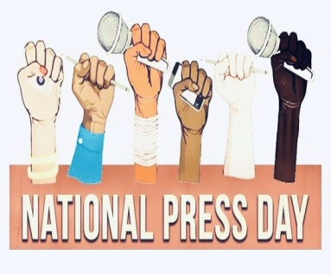
- National Press Day is observed on 16th November every year to celebrate free and responsible press in India.

- On this day the Press Council of India started functioning as a moral watchdog to ensure that the press maintains high standards and is not constrained by any influence or threats. It also commemorates the day when the Press Council of India started functioning.

- In 1956, the First Press Commission was planned to form a Press Council to protect freedom of the press in India. On 4 July 1966, the Press Council was established in India.

- It came into effect from 16 November 1966 under the Press Council Act of 1978. Therefore, 16 November is celebrated as National Press Day every year.

