Dominican quest bug report :- 06 Dec 2018
Front end:
http://172.104.212.99/
1-http://172.104.212.99/admin/internal_booking/2/12 :- In booking page edit is not working , when we want to change some detail. DONE
2- In admin section Phone number and mobile no is not working , but the booking is complete , mobile number category must be in booking process. DONE
3- http://172.104.212.99/booking-form/?source=5&des=16&type=private&trip=onw_way on the booking when we want to select 1 amenities other amenities also selected .DONE
4- http://172.104.212.99/booking-form/?source=5&des=16&type=private&trip=onw_way on the booking hour and minute list is coming 1, 2, 3 . other hour and minutes is not showing properly . DONE
5- http://172.104.212.99/booking-form/?source=5&des=16&type=private&trip=onw_way on the booking when we select amenities and after that the sum of total drinks USD is not showing . NOT DONE . It is showing when we submit the form , but it should be come when we select the amenities.//
6- http://172.104.212.99/booking-form/?source=5&des=16&type=private&trip=onw_way on the booking after filling all the form submit is not working . The booking is not completed yet. DONE
7- http://172.104.212.99/booking-form/?source=5&des=16&type=private&trip=onw_way on the booking when we select passenger it is also showing 0 passenger . NOT DONE
8- http://172.104.212.99/booking-form/?source=5&des=16&type=private&trip=onw_way on the booking when we add some amenities , add button is not clickable. NOT DONE
9- http://172.104.212.99/booking-form/?source=5&des=16&type=private&trip=onw_way on the booking when we filling the form, Your Pickup Time on this day will be at: 03.25pm , it is always showing. No another time is showing for the booking process. DONE
10- http://172.104.212.99/contact-us in contact us page when we submit the contact us form it is submitting. But email is not received . NOT DONE
11- http://172.104.212.99/my-bookings in my booking section some information is up to the border line.
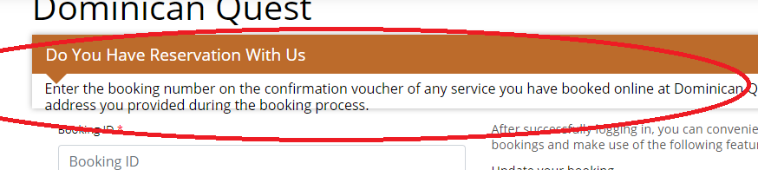 NOT DONE
12- http://172.104.212.99/about-us in about us page some information is up to the border line. And very close to the list.
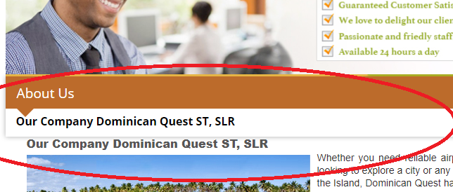 NOT DONE
13- http://172.104.212.99/faq in FAQ section some information is outside the border line. It should be some space in that line. NOT DONE
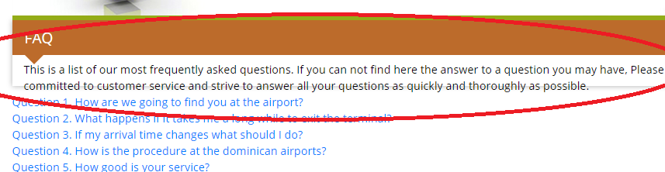
14- In language section when we change the format of ( Spanish, Russian, German and French ) , somewhere it is also coming in English format . it is not changing. NOT DONE
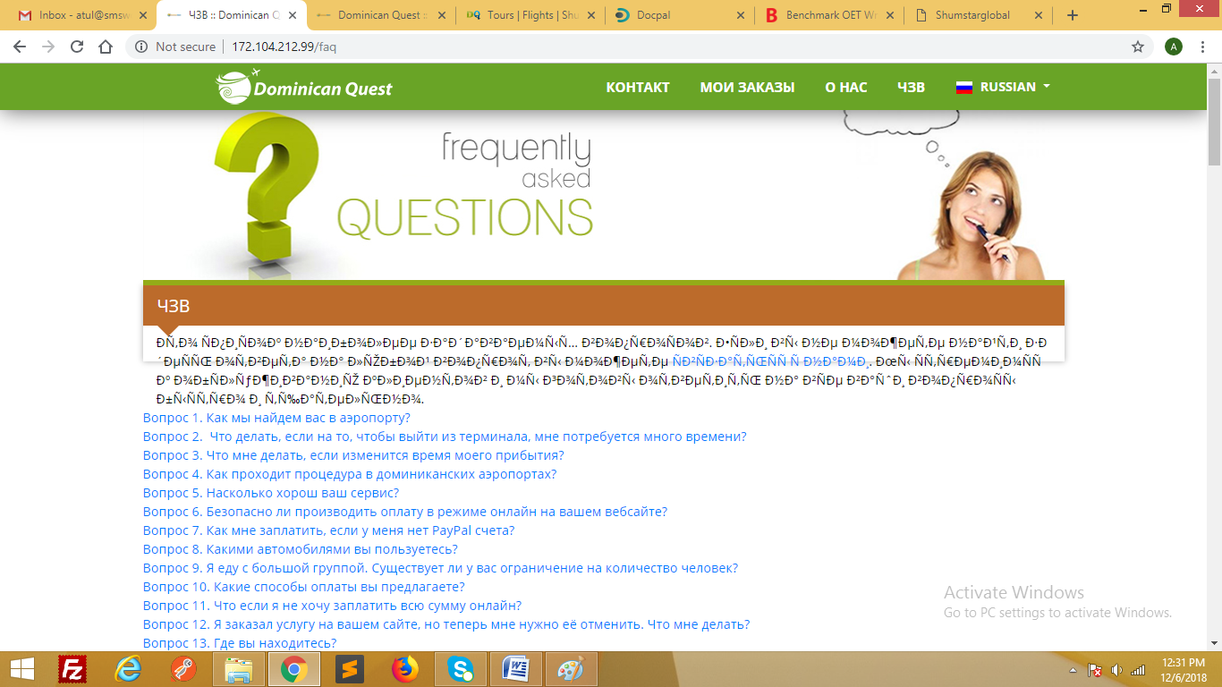

15- http://172.104.212.99/faq Language should be also in that particular language , when we change it . it is not changing also. NOT DONE
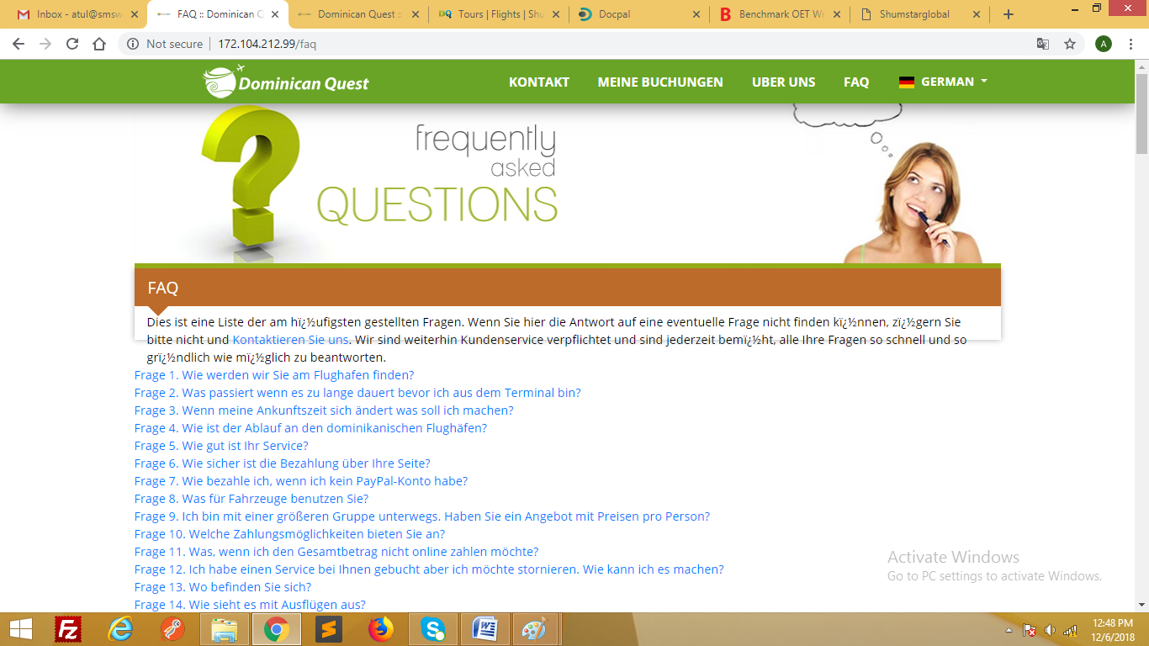
16- http://172.104.212.99/booking-form/?source=16&des=5&type=private&trip=onw_way In language section when we change the format of ( Spanish, Russian, German and French ) , the booking process form is also coming in English process.
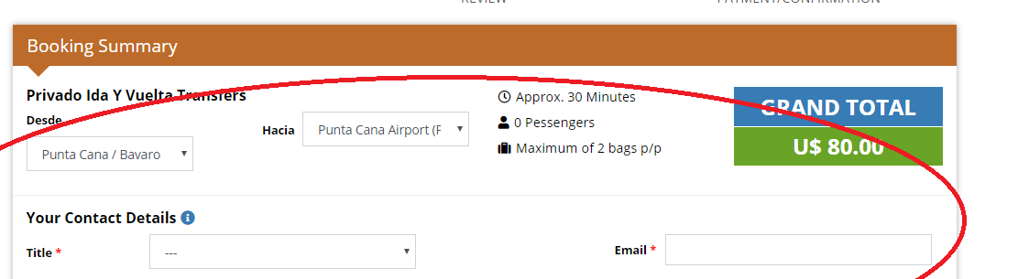
17- http://172.104.212.99/booking-form/?transfer=NjE=&trip=one_way when we add amenities it is directly goes to admin section. NOT DONE //Showing 404
18- http://172.104.212.99/booking-form/?transfer=NjE=&trip=one_way when we fill up the booking process and after that we submit the booking form , it is directly goes to admin section. NOT DONE

3 JANUARY BUG REPORT BY ATUL :-
FRONT END:-

http://172.104.212.99/ Private Transfer :-
- http://172.104.212.99/booking-form/one_way/NjE= When we select some amenities it is selecting ,but when we click on add drinks it is not clicking.
- http://172.104.212.99/booking-form/one_way/NjE= Total for drinks is also not showing. It is showing when we submit the booking form.
- http://172.104.212.99/booking-review/MjY= When we submit the booking form , don’t receive any booking message on email id and number also.
- http://172.104.212.99/booking-review/MjY= When we submit the booking form , total for drinks value is showing wrong .

Shared Transfer :-
- http://172.104.212.99/search-result/?source=5&des=16&type=shared When we select shared transfer , it is also showing prices of our private transfer. It is showing like that.

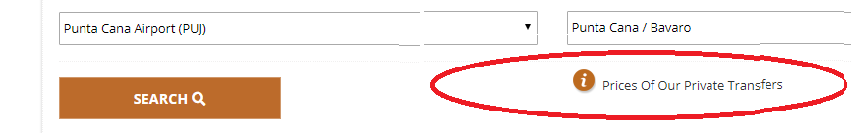
- http://172.104.212.99/booking-form/one_way/MzAz At the booking form when we select shared transfer , at booking summary it is showing private one way transfer,but it should be come shared one way transfer.

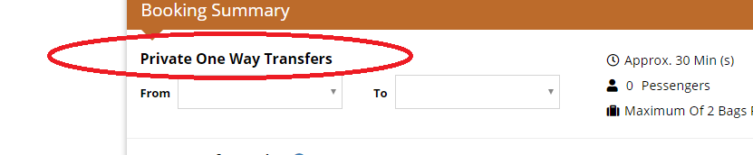
- http://172.104.212.99/booking-form/one_way/MzAz At the booking form it is not selecting any option to book from section. FROM section is no option to select.
- http://172.104.212.99/booking-form/one_way/MzAz At the booking form it is not selecting any option to select destination. TO section is empty it don’t have any data to select.
- http://172.104.212.99/booking-form/one_way/MzAz At the booking form when we add drinks , it is not adding.

