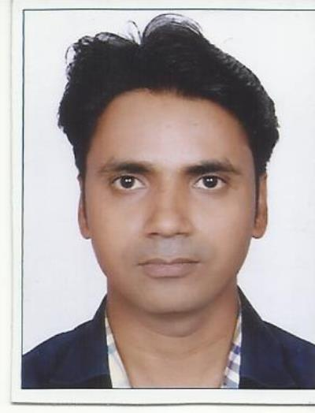
Shiv Saurabh

M.Tech (YMCAUST Faridabad)
Email ID: shivsaurabh@gmail.com Contact No. +919580222233 D.O.B :03/07/1985

Career Objective
Seeking a responsible post for giving the profound knowledge which makes the career progressive.

Career Summary

Date |  | Total experience | College
from | To | Total experience | College
JUL-1/2008 | JUN-30/2010 | 2 years | VBCET Kanpur(UPTU)
AUG-1/2010 | JUL-31/2012 | 2 Years | YMCAUST Faridabad
NOV-11/2012 | JULY-31/2014 | 1 year and 8 month | ASET Bijwasan(GGSIPU)
AUG-15/2014 | Till date | 5 years | Freelancer ( GATE/PSU)

    - A progressive and multitalented lecturer with extensive practical knowledge having more than 5 years’ experience as Engineering college faculty.
    - 5 years’ experience as Various coaching faculty and cities (Delhi, Agra, Kanpur, Noida, Jaipur, Allahabad, Lucknow etc.) currently associated with Dronacharya institute Jaipur.
    - Excellent knowledge of electrical technology and the new methodologies.
    - Proficient in managing the opportunities for students.
    - Excellent in providing the real time knowledge about technology.
    - Excellent knowledge of subject and also have great practical knowledge.
    - Proficient in giving practical knowledge.

Subject tutored
    - Electrical Machine (GATE/PSU/AE/JE)
    - Power Systems (GATE/PSU/AE/JE)
    - Network Systems (GATE/PSU/AE/JE)
    - Electrical Network (GATE/PSU/AE/JE)

Academic Details

Qualification | University | Year | Percentage
M.Tech  (Power System and Drives) | YMCAUST Faridabad | 2012 | 6.943 CGPA
B.TECH  (Electrical and Electronics) | UPTU,Luckow | 2007 | 65.6
Intermediate | UP Board | 2002 | 77.2
High School | UP Board | 2000 | 67

Personal Qualities
    - Excellent Presentation, motivational and leadership skills.
    - Strong analytical, logical and mathematical skills.
    - Ability to handle the students.
    - Ability to provide quality knowledge.

Key Responsibilities Handled
    - Provide conceptual knowledge and make them visualize the things.
    - Identify the weak points of students.
    - Provide the help during the project.
    - Provide support to weak students.
    - Act as an Assistant Controller of Examination at ASET Bijwasan for two semesters.

Achievements

    - Three times Gate Qualified.
    - Two times Excellent Faculty award at ASET Bijwasan and VBCET Kanpur.
    - Two Years Teaching Assistantship experience @ YMCAUST, Faridabad.
    - Published a paper on Sensorless Speed Control of 3-phase Induction Motors by using several techniques with impact factor of 1.252 at IJERSTE.
    - Presented a paper on “A fuzzy logic controller based DC-DC Boost converter for load voltage control” at a workshop sponsored by ISTE at YMCA University of Science & Technology, Faridabad.
    - Attended a workshop on Nanotechnology and Embedded Systems, sponsored by ISTE during 23rd July to 3rd August at YMCA University of Science & Technology, Faridabad.
    - IELTS score of 6.0 in NOV 2014.
    - 1st rank in 10th & 12th in my college.
    - 1st position in PHYSICS in state (U.P.) in 12th.

Seminars

- Delivered a seminar on the topic “Compensation in Power Systems” and prepared a report on the same.
- Seminar on Unified Power Flow Controller.
- Seminar on Transients Over voltages in Electrical Distribution systems.

Date
Place Shiv Saurabh

